20462075 – Jasinge Don Sahas Renuja Gunasekara

Question 1

2. -> (i) If the user is not engaging during the requirement elicitation period the project manager has no clue of what their requirements are. So there is a lot of guesswork involved when determining the functional and nonfunctional requirements of the end user which results in an inconsistent project scope.
3. -> (ii) If there is little to no teamwork within the development team this leads to the project being delayed as there is no coordination and planning when it comes to deciding what items to do in the sprint planning etc. This also creates a toxic work environment which decreases the productivity of the developers.
4. -> (iii) If we don’t map the requirements properly of the client, this leads to the client receiving an end software that is not suitable to his/her needs which leads to the client being not satisfied.
5. -> (iv) If we are unable to test the system consistently this leads to us not being able to test whether the system is doing what it said it would do which is part of verification.

(d) -> (ii) Since testing is part of the development cycle as well, if we have inconsistent testing then we are unable to finally handover the system to the end customer which means the project will be delayed.

(a) -> (iii) The lack of end-user engagement during requirement elicitation means that we will build a system that is not up to the requirements of the customer (because we don’t know what they were in the first place) which leads to the client not being satisfied.

(II)

1. ABC College Management, Students, Teachers (Assumption).
2. Three of the main stages would be Analysis (to identify the necessary requirements of the system), Design (to map the client’s requirements, to a functional system), and the Development and Implementation (where we develop the system from the ground up).

If we use a Commercially Available Enrolment System, we have a “What you see is what you get” view since we are unable to change and manipulate this system (Assuming it is copyrighted which it probably is) to ABC College Management’s needs, there might also be issues with auxiliary interfaces and whether it is able to work with other existing systems used by ABS College. If we develop a system from the ground up we are able to custom tailor a system that is not only suited to ABC College’s system’s needs, but also ensure that it works well with other existing systems. However, a tailor-made software will cost a lot more than the commercially available enrolment system.

1. The core goal of the ABC College is to ensure that it students are able to enroll/drop into their classes in automated process.

We can measure the objectives by quantifying the benefits by setting benefits such as:

1. Reduction of x staff, saving $y
2. Increase in enrolment speeds by x%

Etc. This is how we will be able to measure the effectiveness of the system in achieving its objectives.

1. 1. As a Student, I want to enroll in a class, so I can take that class.
   2. As a Student, I want to drop a class, so I can remove a class that I don’t want to attent.
   3. As a Teacher, I want to add a class, so I can add a class that students can enroll into.
   4. As a Teacher, I want to remove a class, so I can remove a class that I no longer teach.

(III)

|  |  |  |
| --- | --- | --- |
| UML Use Case | UML Sequence | UML Activity |
| Use case modeling is used to design a system in how the expected behavior should work. Without going into detail on how the exact functionality works.  It shows some of the relationships between the use cases and actors and how they interact with the system. | These are diagrams that show how certain activities are carried out. They often deal with one use case. As opposed to the Use Case diagram which shows a general summary. It is also a high-level abstraction on how objects interact with other objects in the system. | This is a diagram that is an advanced flow chart of sorts which shows the workflows of objects and the pre-conditions and post conditions. This goes indepth into how certain activities are undertaken and how they have parallel activities etc. This is less abstract than both Use Case and Sequence. |

(IV)

I will refuse to do so until the Employee gives me consent as I am violating that employee’s privacy. I will also take it up with the higher ups as to needing a clear policy about the handling of emails. It is unethical. If the company has a clear policy about private use and a policy that states that the employee’s emails are monitored, then I would have no qualms in fetching these emails. If the employee has not used the email for private use, they would not mind me giving permission to extract the emails. If the employee has used it for private use, we need to respect their privacy but also the employee needs to come clean about it.

Question 2

1. If you don’t upgrade (Project 1)

|  |  |  |  |
| --- | --- | --- | --- |
| Possibility | Chance | Income | Expected |
| No Competition | 10% | 350,000 | 35000 |
| Competition Exists | 20% | 50,000 | 10000 |
| Beating the Competition | 70% | 100,000 | 70000 |
|  |  | Expected Income Per Year | 115,000 |

If you upgrade (Project 2)

|  |  |  |  |
| --- | --- | --- | --- |
| Possibility | Chance | Income | Expected |
| No Competition | 40% | 350,000 | 140,000 |
| Competition Exists | 10% | 50,000 | 5,000 |
| Beating the Competition | 50% | 100,000 | 50,000 |
|  |  | Expected Income Per Year | 195,000 |

|  |  |  |
| --- | --- | --- |
| Year | Project 1 | Project 2 |
| 0 | -200,000 | -200,000 |
| 1 | (115,000-30000) | (115,000-30,000) |
| 2 | (115,000-30000) | (195,000-30,000-3000) |
| 3 | (115,000-30000) | (195,000-30,000-3000) |
| 4 | (115,000-30000) | (195,000-30,000-3000) |
| 5 | (115,000-30000) | (195,000-30,000-3000) |
| Net Profit | 225,000 | 533,000 |

Yes it is advisable to go ahead with the project as just for a small increment in operation costs, you can almost double your profit.

Assumption Y1, the expected income is going to be 115,000 in Project 2 since they haven’t upgraded it yet.



|  |  |  |
| --- | --- | --- |
| Year | Cash-flow | Accumulated |
| 0 | -45,000 | -45,000 |
| 1 | -2,000 | -47,000 |
| 2 | 13,000 | -34,000 |
| 3 | 17,000 | -17,000 |
| 4 | 29,000 | 12,000 |
| 5 | 100,000 | 112,000 |

1. Payback was in between 3rd and 4th year. 3.7 Years for one decimal point.
2. ROI = Average Annual Profit / Total Investment * 100

Average Ann Profit = Tot Profit / Num Years => 112,000 / 5 = 22,400

Total Investment = 137,000

22,400 / 137,000 * 100 = 16.3%



|  |  |  |  |
| --- | --- | --- | --- |
| Year | Cash Flow | Discount Rate of 5% | Discounted Cash Flow |
| 0 | -45,000 | 1 | -45,000 |
| 1 | -2,000 | 0.9523 | -1,904 |
| 2 | 13,000 | 0.9070 | 11,791 |
| 3 | 17,000 | 0.8638 | 14,685 |
| 4 | 29,000 | 0.8227 | 23,858 |
| 5 | 100,000 | 0.7835 | 78,350 |
| NetProfit | 112,000 | NPV | 81,780 |

Discount Factor = 1 / (1 + r)^t

Question 3

(I)

(a) Project Risk 1: Do we have the budget to pay for the developers to build an update? If it is a security vulnerability, chances are we made the call to not develop some security features because of budgetary constraints. Therefore, do we have the money to build an update now?

Project Risk 2: Schedule Problems, are we able to build, test and push an update in time? Is the exploit vulnerability being exploited by many people? Can we create the update in time to cover this risk?

Technical Risk 1: Can we integrate an update safely to cover up this security vulnerability? By fixing this update will we create a different vulnerability? Are we able to implement this design safely into the system?

Technical Risk 2: Implementation Risk, can we even properly push an update that is able to cover up this risk? Do we have the technical know-how to do so? Or is a vulnerability of a dependency that we don’t even own or understand?

(b) Risk Exposure it the potential loss resulting from some activity that is quantified. In this situation we can calculate a monetary amount for the loss of information/leaking of vaccination details, and we can determine the probability in which it will happen (10% of users etc). Then we can use the formula:

Risk Exposure = Probability x Loss Magnitude; to determine the Risk Exposure.

(c) A Risk Classification Matrix is a tool that is used to determine the probability in which certain risks can happen and the severity / loss of magnitude of such risks. This is done in the Risk Analysis part of the development so we can identify risks and chart them accordingly so we can respond to them as well.

In this scenario we can identify the risk of a data leak which has a high impact, and a high probability, we need to focus our efforts on developing an intervention mechanism to prevent such risk from occurring. Hypothetically if there was a risk of someone hacking and spreading false messages on the application which has a low chance of happening and a low impact, then we can deprioritize developing an intervention mechanism for that. This allows us to identify the risks properly.

(II)

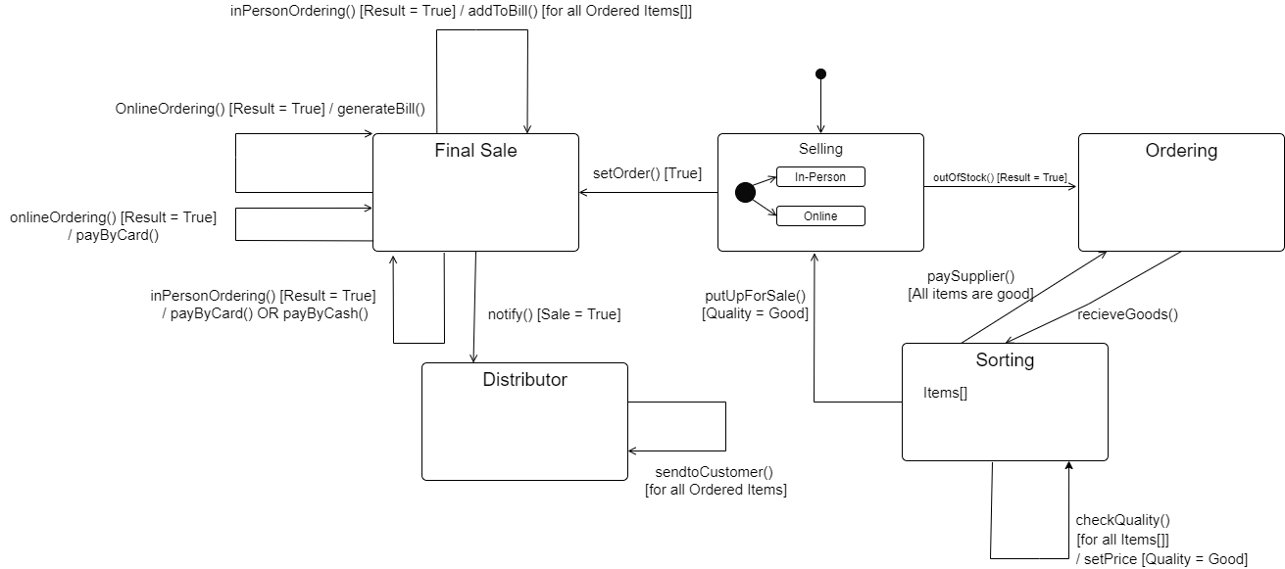

Question 4



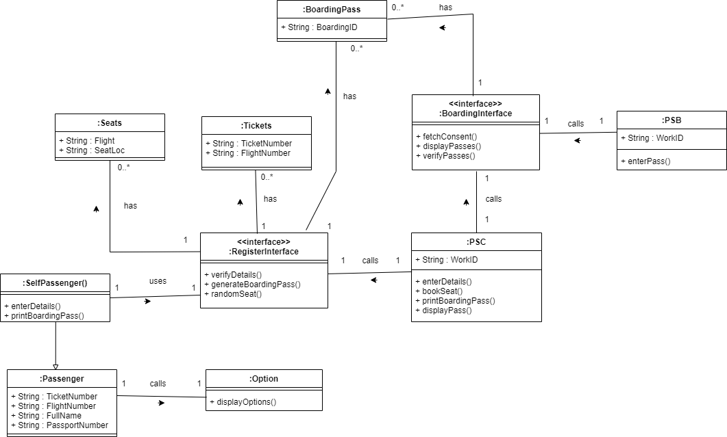

Assumed that if you’re self-checking in, you don’t get to choose the seat. enterDetails() refers to all the required details being entered. Only a self-passenger class is there to distinguish as the only interactions the other two types of passengers have are minimal with the system since PSC will be handling them.



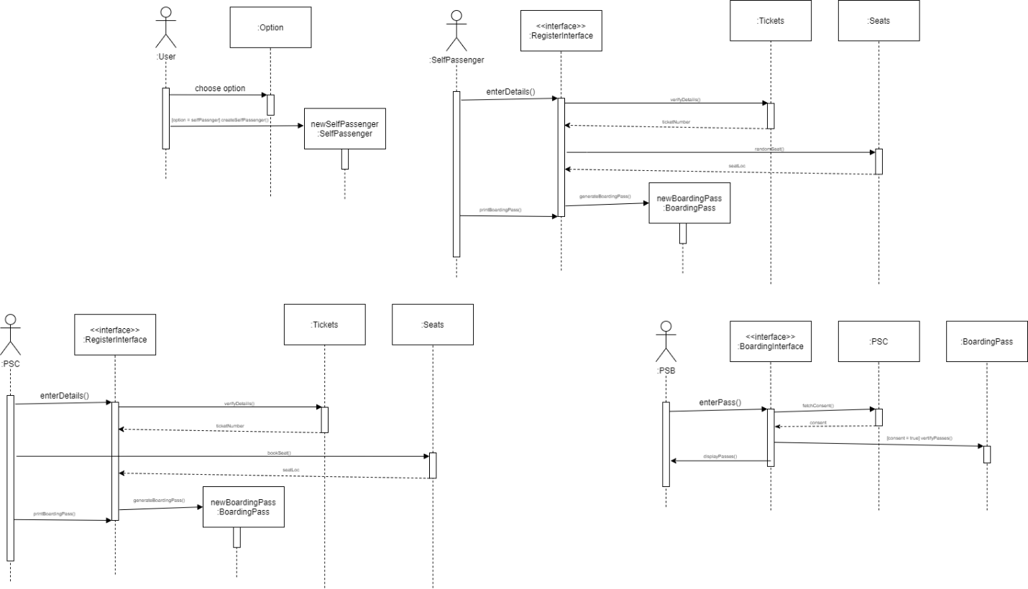



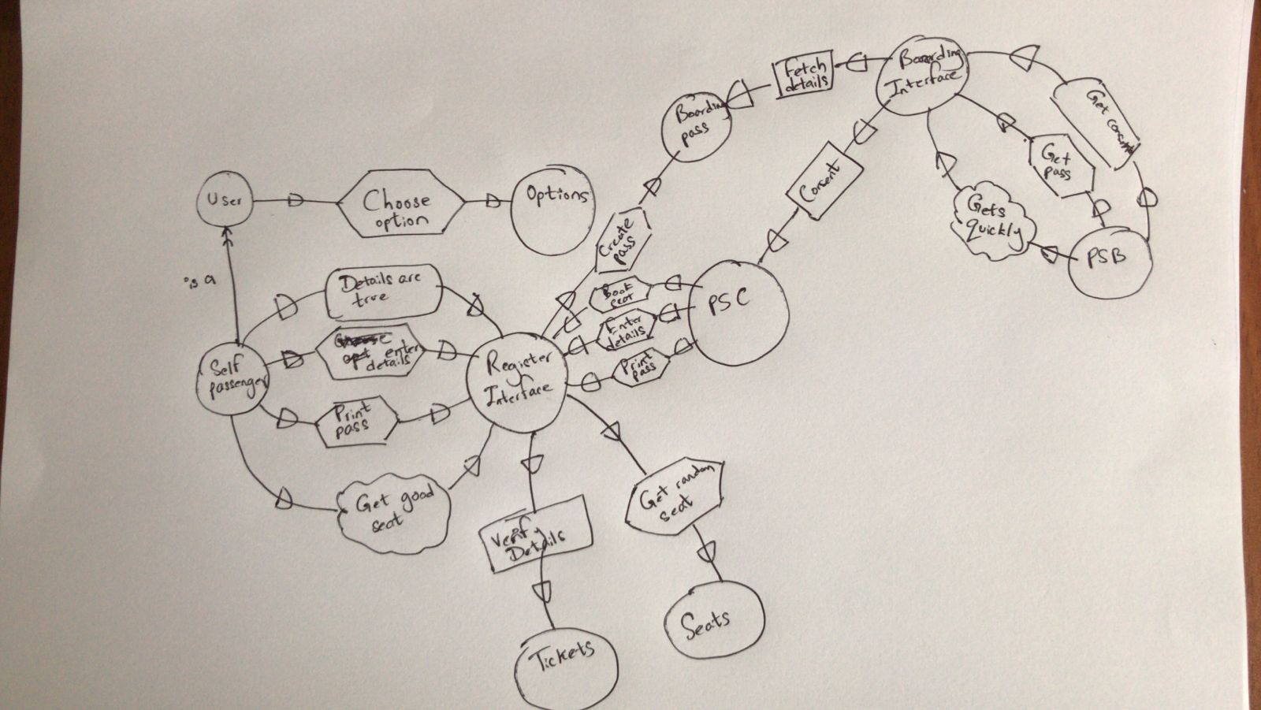

I apologize for the seemingly untidy work, I ran out of time and my mouse broke so it would’ve taken me a long time to draw using draw.io using the trackpad on my laptop, hope you would understand.

1. 1. The System must allow the User to choose between the options for check-in.
   2. The System must allow the PSC Desk Staff to verify the ticket details.
   3. The System must allow the PSC Desk Staff to reserve a seat.
   4. The System must allow the PSC Desk Staff to generate a boarding pass.
   5. The System must allow the User to enter their details in the self-checking option.
   6. The System must verify the User’s details in the self-checking option.
   7. The System must generate a boarding pass to the User if the details are true.
   8. The System must allow the PSC Desk Staff to send the PSB Staff the list of passengers.
   9. The System must allow the PSB Staff to request the PSC Desk Staff for the list of passengers.
   10. The System must allow the PSB Staff to verify the details of the boarding pass.